**Write queries to return the following:**

1. Display a list of all property names and their property id’s for Owner Id: 1426.

--a. Display a list of all property names and their property id’s for Owner Id: 1426.

SELECT p.Name AS 'Property Name',

p.Id as 'Property ID'

FROM Keys.dbo.Property p

INNER JOIN Keys.dbo.OwnerProperty op ON p.Id = op.PropertyId

WHERE op.OwnerId = 1426;

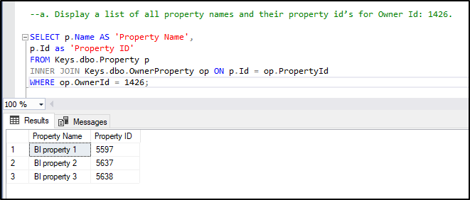

1. Display the current home value for each property in question a).

--b. Display the current home value for each property in question a).

SELECT p.Name AS 'Property Name',

p.Id as 'Property ID',

pf.CurrentHomeValue AS 'Current Home Value'

FROM Keys.dbo.Property p

INNER JOIN Keys.dbo.OwnerProperty op ON p.Id = op.PropertyId

INNER JOIN Keys.dbo.PropertyFinance pf ON op.PropertyId = pf.PropertyId

WHERE op.OwnerId = 1426;

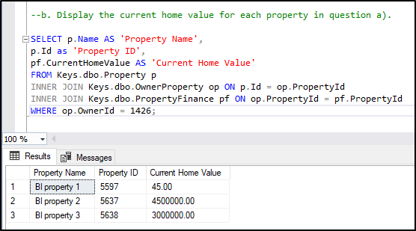

1. For each property in question a), return the following:
2. Using rental payment amount, rental payment frequency, tenant start date and tenant end date to write a query that returns the sum of all payments from start date to end date.
3. Display the yield.

SELECT

p.Name AS 'Property Name',

p.Id as 'Property ID',

tp.PaymentAmount,

tp.StartDate,

tp.EndDate,

tpf.Name as 'Payment Cycle',

CASE

WHEN tp.PaymentFrequencyId = 1 THEN tp.PaymentAmount * 52

WHEN tp.PaymentFrequencyId = 2 THEN tp.PaymentAmount * 26

WHEN tp.PaymentFrequencyId = 3 THEN tp.PaymentAmount * 12

ELSE 0

END as 'Total Amount'

FROM Keys.dbo.Property p

INNER JOIN Keys.dbo.OwnerProperty op ON p.Id = op.PropertyId

INNER JOIN dbo.TenantProperty tp ON op.PropertyId = tp.PropertyId

INNER JOIN dbo.TenantPaymentFrequencies tpf ON tp.PaymentFrequencyId = tpf.Id

WHERE op.OwnerId = 1426;

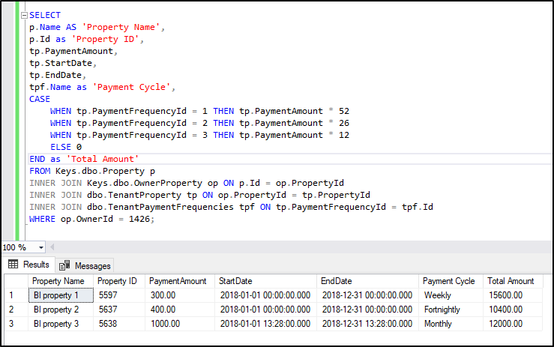

1. Display all the jobs available

SELECT

*

FROM dbo.Job j

INNER JOIN dbo.JobStatus js ON j.JobStatusId = js.Id

WHERE j.JobStatusId in (1, 2, 3);

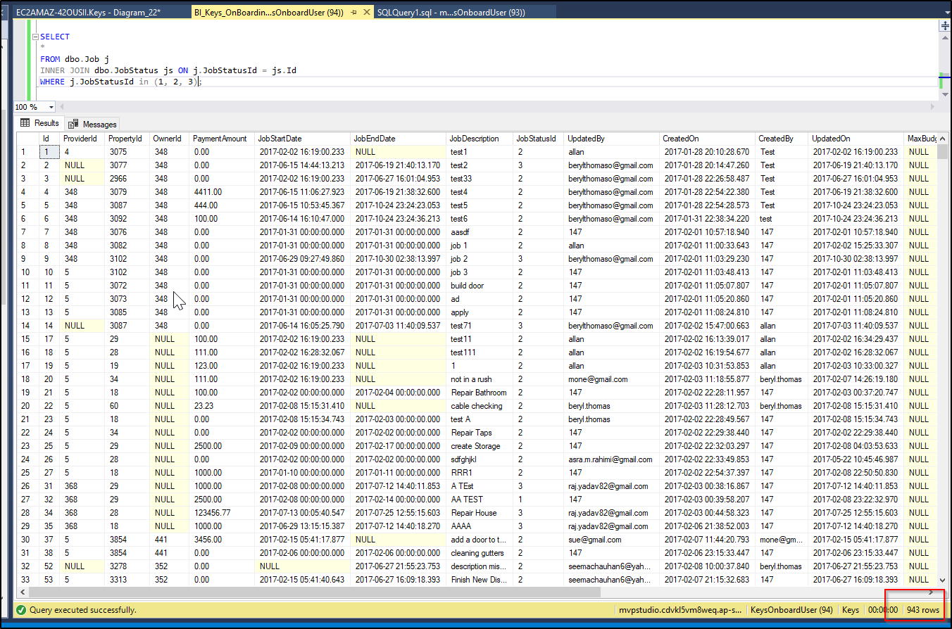

1. Display all property names, current tenants first and last names and rental payments per week/ fortnight/month for the properties in question a).

SELECT

p.Id as 'Property ID',

p.Name AS 'Property Name',

pn.FirstName,

pn.LastName,

tp.PaymentAmount,

tpf.Name as 'Payment Cycle'

FROM Keys.dbo.Property p

INNER JOIN Keys.dbo.OwnerProperty op ON p.Id = op.PropertyId

INNER JOIN dbo.TenantProperty tp ON op.PropertyId = tp.PropertyId

INNER JOIN dbo.Person pn ON tp.TenantId = pn.Id

INNER JOIN dbo.TenantPaymentFrequencies tpf ON tp.PaymentFrequencyId = tpf.Id

WHERE op.OwnerId = 1426

AND tp.IsActive = 1;

